Introduction:

Like to take a moment to thank you for honoring our company with your business. Taking on a fundraising event is always stressful. The allotment for this is $100,000 can be overwhelming. Our company has a captivating plan to bring success to your endeavors. We have viewed other successful campaigns, assessed the keys to their progress, combined with your brilliant ideas to bring you a statistically supported plan.

Findings

First, we turned our focus on the money raised by various campaigns. Because Louise estimates that her play will cost $12,000, we researched projects with a similar monetary goal. Upon organizing the data, many of the campaigns missed their goal amount by a small margin. In finding the percentage of a campaign's funding we quickly determine how close a campaign came to reaching, exceeding their funding goal at times.

Kickstarter is allowing project creators to add incentives for different pledge amounts, so we determined how much money people pledged to campaigns historically. In discovery, we found on the average pledge $4.02 per person.

Theater Category

Kickstarter requires every campaign to have a fundraising goal and in view of your interest in starting a campaign for theater, we filtered the worksheet to show only theater campaigns. Breaking this down, the chart illustrates the following: 58% successful, 38% failed, 3% canceled, 1% live outcomes.

Subcategories

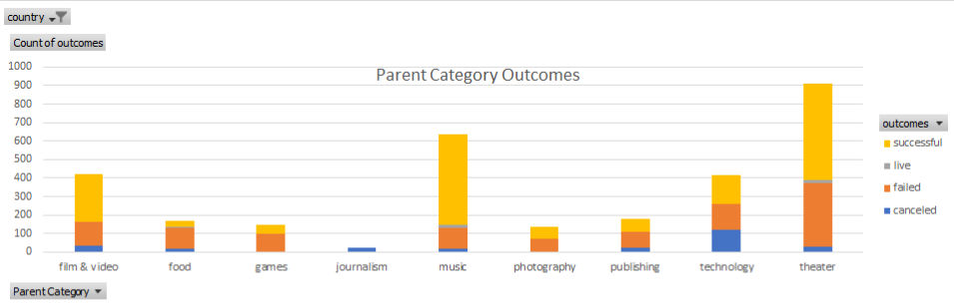To put the theater data into perspective, an analysis of all its subcategories (like science fiction, drama, animation, and so on). While looking at the theater data as a whole has been helpful, including more data will make our analysis even more detailed and thus generate additional insight. In using subcategories, we are focusing our analysis on an area that is more relevant for Louise: theatrical productions. From the chart theater provides a solid successful outcome but music and film & video do as well.

Duration

Turning our attention to the length of fundraising campaigns will provide valuable piece of data. Is the length of a campaign correlated with its success? To assist in your campaign timeline, we took a look at how campaign length might be tied to its outcome.

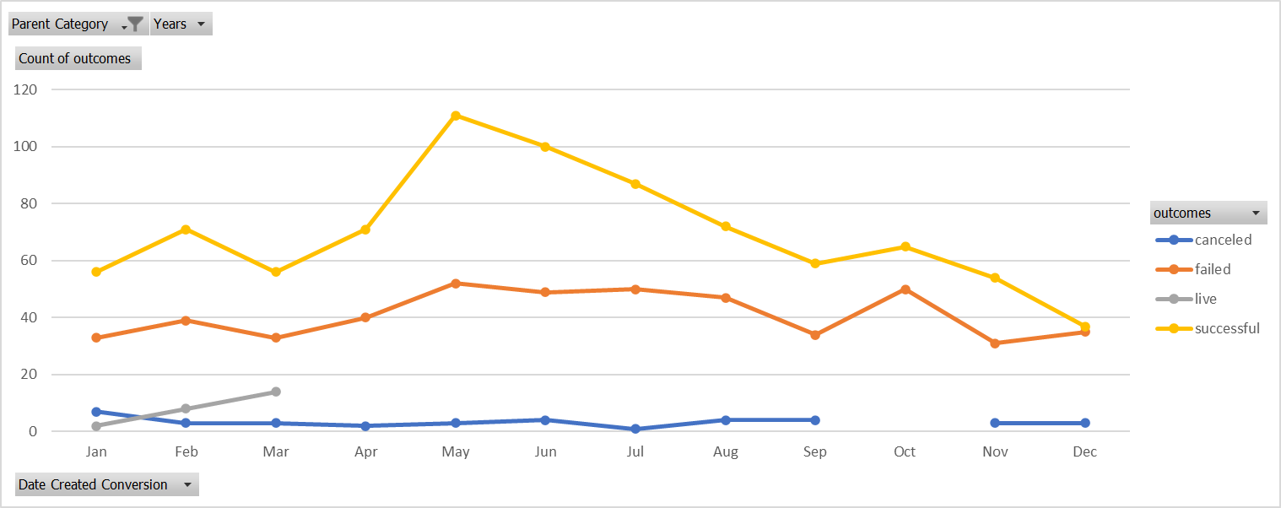

Monthly Outcomes for Theater

May launched the most successful Kickstarter campaigns with a high of 111, ranging from 33-111. However, mouths to steer clear of are January, June, July and October all had roughly the same number of failed campaigns launched as determined by examining the points along the trend lines of the chart. June appears to be your most advantageous time to launch a campaign

Scope and Type

Focusing on unique campaigns similar to your vision, we felt this would provide critical information to assist in your project’s success. Looking again at the chart above we can conclude, a spike of successful campaigns exists in June, but that tapers off by the end of the year. In contrast, the data around technology campaigns reveals one large spike, their trend lines are a bit all over the place and less predictable. However, music provides a rather consistent successful outcome.

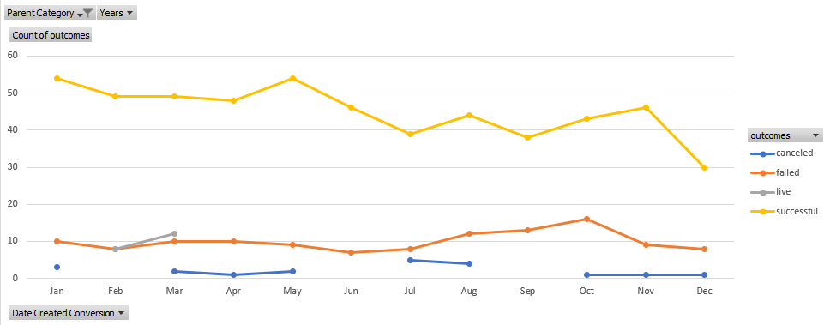

Monthly Outcomes for Music

Theater Specifically

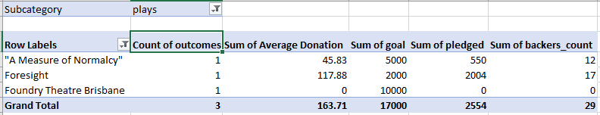From our interview with you, we gather that you favor the play: *Foresight* and have a curiosity toward the market in Great Britain. The statistics reveal a success campaign, reaching 100% of its goal and exceeding it by four dollars. The average donation is relatively high, especially since there are only 17 backers.

Foresight Comparison with Other Plays Outcomes

Understanding your interest in the Edinburgh Festival Fringe, the table below provides a comparison is made between these five plays and Foresight. Significant to note is the sum of average donations and the backers for the five plays verses the Foresight.

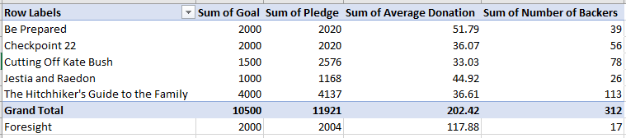

Foresight Comparison with Edinburgh Festival Fringe Plays Outcomes

|  |  |  |
| --- | --- | --- |
| Successful vs. Failed Campaigns | | |
|  | Successful | Failed |
| Mean Goal | 5049 | 10554 |
| Median Goal | 3000 | 5000 |
| Standard Deviation of Goal | 7749 | 21968 |
| Upper Quartile of Goal | 5000 | 10000 |
| Lower Quartile of Goal | 1500 | 2000 |
| IQR of Goal | 3500 | 8000 |
|  |  |  |
| Mean Pledged | 5602 | 559 |
| Median Pledged | 3168 | 103 |
| Standard Deviation of Pledged | 8335 | 1331 |
| Upper Quartile of Pledged | 5699 | 501 |
| Lower Quartile of Pledged | 1717 | 9 |
| IQR of Pledged | 3982 | 492 |

Successful vs. Failed Campaigns

Finally, major contributing factor behind the successful campaigns is the monetary goals. Failed Kickstarter’s campaign have a significantly higher goal as well as their pledges were substantially lower. The IQR of pledged and of the goal is three time the standard deviation indicating a few of the failed Kickstarters have some extreme dreaming occurring.

Recommendations

The data supports your idea for a theater campaign, but it does have a drop off curve of success so possibly combining theater and music campaign might provide consist of flow of money. June looks like an opportunistic time to have Foresight at the theater. Finally, a meeting might be to discuss the importance of setting realistic goals.